12.1 Source File
Index.html
<!DOCTYPE html>
<html>
<head>
<title>Plugging into the Future</title>
<link href="https://cdn.jsdelivr.net/npm/bootstrap@5.3.2/dist/css/bootstrap.min.css" rel="stylesheet">
</head>
<body>
<nav class="navbar navbar-expand-lg navbar-dark bg-dark">
<div class="container-fluid">
<a class="navbar-brand" href="/">Electricity Analytics</a>
<button class="navbar-toggler" type="button" data-bs-toggle="collapse" data-bs-target="#navbarNav">
<span class="navbar-toggler-icon"></span>
</button>
<div class="collapse navbar-collapse" id="navbarNav">
<ul class="navbar-nav ms-auto">
<li class="nav-item"><a class="nav-link" href="/">Home</a></li>
<li class="nav-item"><a class="nav-link" href="/about">About</a></li>
<li class="nav-item"><a class="nav-link" href="/dashboard1">Dashboard 1</a></li>
<li class="nav-item"><a class="nav-link" href="/dashboard2">Dashboard 2</a></li>
<li class="nav-item"><a class="nav-link" href="/dashboard3">Dashboard 3</a></li>
<li class="nav-item"><a class="nav-link" href="/story">Story</a></li>
</ul>
</div>
</div>
</nav>
<div class="container mt-5">
<div class="text-center">
<h1>Plugging into the Future</h1>
<p class="lead">An Exploration of Electricity Consumption Patterns Using Tableau</p>
<p>
This project analyzes electricity consumption trends across regions,
time periods, and sectors using interactive Tableau dashboards.
</p>
</div>
</div>
</body>
</html>
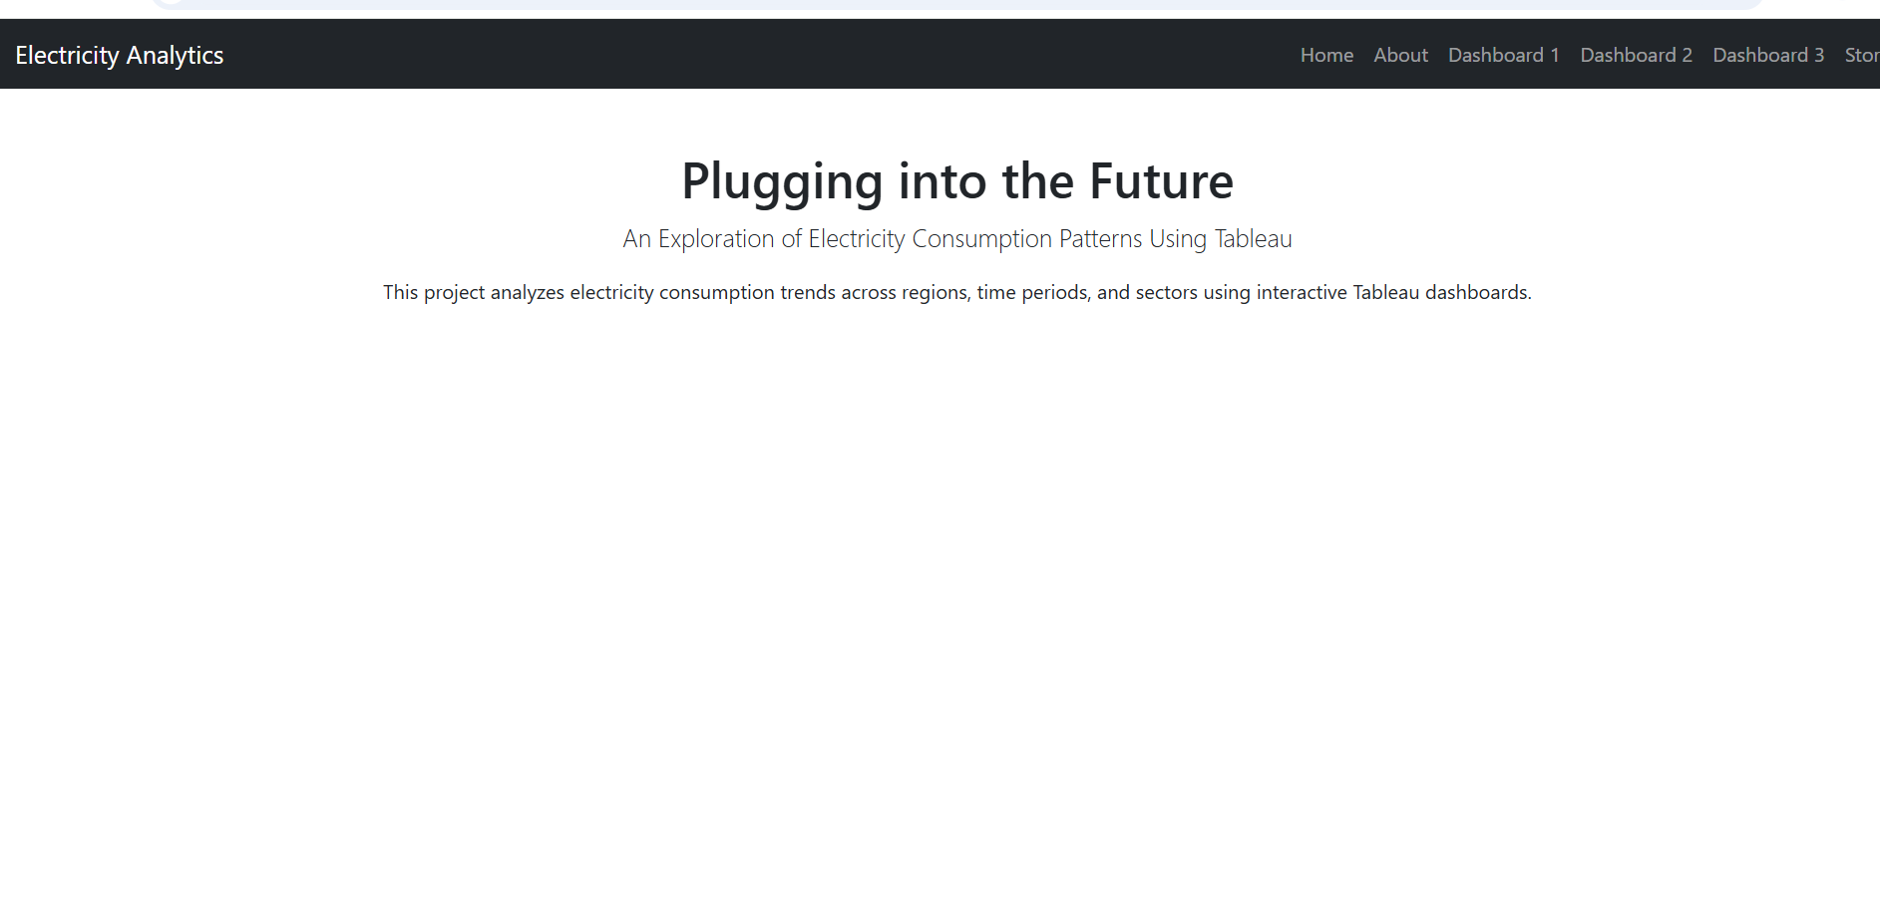
About.html
<!DOCTYPE html>
<html>
<head>
<title>About Project</title>
<link href="https://cdn.jsdelivr.net/npm/bootstrap@5.3.2/dist/css/bootstrap.min.css" rel="stylesheet">
</head>
<body>
<!-- Navbar Here -->
<div class="container mt-5">
<h2>About the Project</h2>
<p>
This project explores electricity consumption patterns using Tableau.
The analysis focuses on:
</p>
<ul>
<li>Yearly electricity consumption trends</li>
<li>Sector-wise consumption analysis</li>
<li>Regional usage comparisons</li>
<li>Forecasting future demand</li>
</ul>
</div>
</body>
</html>
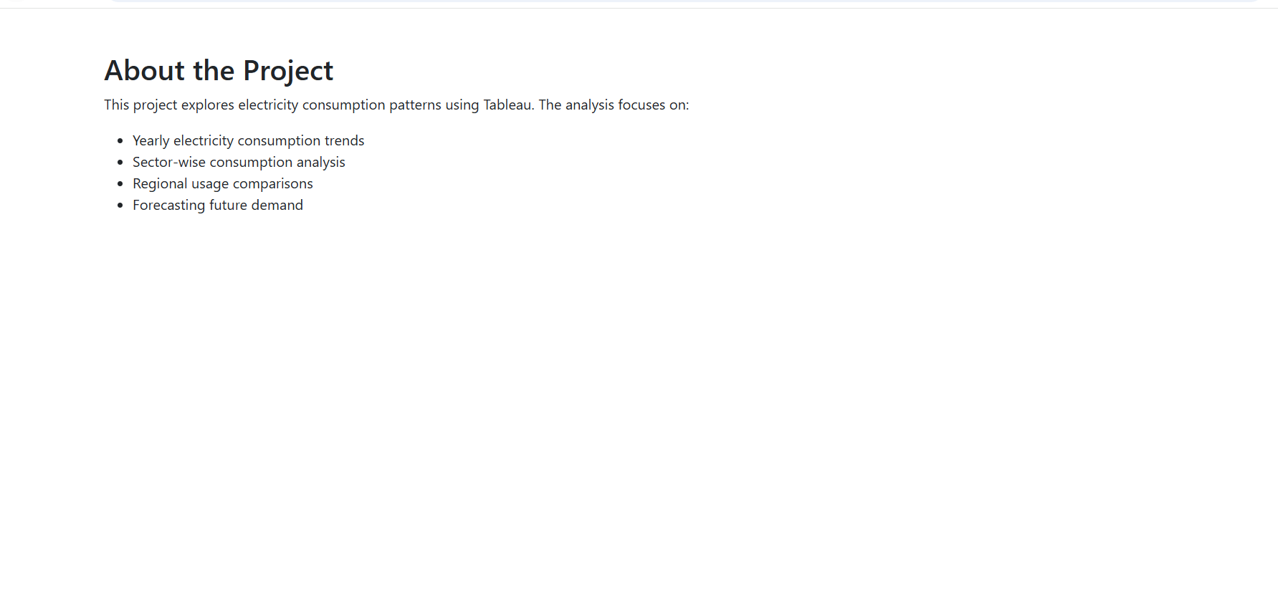

Dashboard1.html
<!DOCTYPE html>
<html>
<head>
<title>Dashboard 1</title>
<link href="https://cdn.jsdelivr.net/npm/bootstrap@5.3.2/dist/css/bootstrap.min.css" rel="stylesheet">
</head>
<body>
<!-- Navbar Here -->
<div class="container mt-4">
<h2 class="text-center">Electricity Consumption Trends</h2>
<div class="mt-4">
<!-- Tableau Embed -->
<div class='tableauPlaceholder' id='viz1771054036972' style='position: relative'><noscript><a href='#'><img alt='Dashboard 1 ' src='https:&#47;&#47;public.tableau.com&#47;static&#47;images&#47;Bh&#47;Bharathsimha-Dashboard1&#47;Dashboard1&#47;1_rss.png' style='border: none' /></a></noscript><object class='tableauViz' style='display:none;'><param name='host_url' value='https%3A%2F%2Fpublic.tableau.com%2F' /> <param name='embed_code_version' value='3' /> <param name='site_root' value='' /><param name='name' value='Bharathsimha-Dashboard1&#47;Dashboard1' /><param name='tabs' value='no' /><param name='toolbar' value='yes' /><param name='static_image' value='https:&#47;&#47;public.tableau.com&#47;static&#47;images&#47;Bh&#47;Bharathsimha-Dashboard1&#47;Dashboard1&#47;1.png' /> <param name='animate_transition' value='yes' /><param name='display_static_image' value='yes' /><param name='display_spinner' value='yes' /><param name='display_overlay' value='yes' /><param name='display_count' value='yes' /><param name='language' value='en-US' /><param name='filter' value='publish=yes' /></object></div> <script type='text/javascript'> var divElement = document.getElementById('viz1771054036972'); var vizElement = divElement.getElementsByTagName('object')[0]; if ( divElement.offsetWidth > 800 ) { vizElement.style.width='100%';vizElement.style.height=(divElement.offsetWidth*0.75)+'px';} else if ( divElement.offsetWidth > 500 ) { vizElement.style.width='100%';vizElement.style.height=(divElement.offsetWidth*0.75)+'px';} else { vizElement.style.width='100%';vizElement.style.height='1877px';} var scriptElement = document.createElement('script'); scriptElement.src = 'https://public.tableau.com/javascripts/api/viz_v1.js'; vizElement.parentNode.insertBefore(scriptElement, vizElement); </script>
</div>
</div>
</body>
</html>
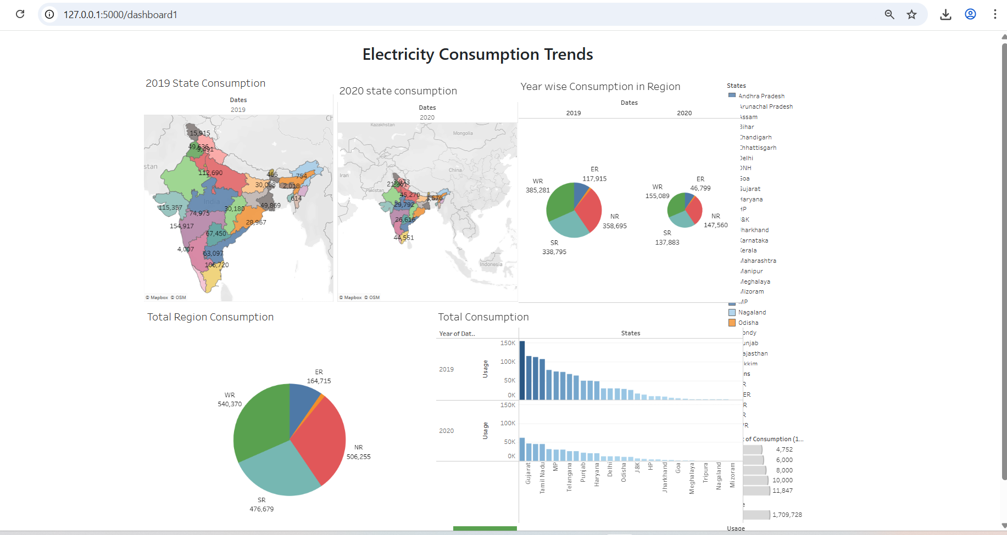
Dashboard2.html
<!DOCTYPE html>
<html>
<head>
<title>Dashboard 1</title>
<link href="https://cdn.jsdelivr.net/npm/bootstrap@5.3.2/dist/css/bootstrap.min.css" rel="stylesheet">
</head>
<body>
<nav class="navbar navbar-expand-lg navbar-dark bg-dark">
<div class="container-fluid">
<a class="navbar-brand" href="/">Electricity Analytics</a>
<button class="navbar-toggler" type="button" data-bs-toggle="collapse" data-bs-target="#navbarNav">
<span class="navbar-toggler-icon"></span>
</button>
<div class="collapse navbar-collapse" id="navbarNav">
<ul class="navbar-nav ms-auto">
<li class="nav-item"><a class="nav-link" href="/">Home</a></li>
<li class="nav-item"><a class="nav-link" href="/about">About</a></li>
<li class="nav-item"><a class="nav-link" href="/dashboard1">Dashboard 1</a></li>
<li class="nav-item"><a class="nav-link" href="/dashboard2">Dashboard 2</a></li>
<li class="nav-item"><a class="nav-link" href="/dashboard3">Dashboard 3</a></li>
<li class="nav-item"><a class="nav-link" href="/story">Story</a></li>
</ul>
</div>
</div>
</nav>
<div class="container mt-4">
<h2 class="text-center">Sector-wise Consumption Analysis</h2>
<div class="mt-4">
<!-- Tableau Embed -->
<div class='tableauPlaceholder' id='viz1771054281028' style='position: relative'><noscript><a href='#'><img alt='Dashboard 2 ' src='https:&#47;&#47;public.tableau.com&#47;static&#47;images&#47;Bh&#47;Bharathsimha-Dashboard2&#47;Dashboard2&#47;1_rss.png' style='border: none' /></a></noscript><object class='tableauViz' style='display:none;'><param name='host_url' value='https%3A%2F%2Fpublic.tableau.com%2F' /> <param name='embed_code_version' value='3' /> <param name='site_root' value='' /><param name='name' value='Bharathsimha-Dashboard2&#47;Dashboard2' /><param name='tabs' value='no' /><param name='toolbar' value='yes' /><param name='static_image' value='https:&#47;&#47;public.tableau.com&#47;static&#47;images&#47;Bh&#47;Bharathsimha-Dashboard2&#47;Dashboard2&#47;1.png' /> <param name='animate_transition' value='yes' /><param name='display_static_image' value='yes' /><param name='display_spinner' value='yes' /><param name='display_overlay' value='yes' /><param name='display_count' value='yes' /><param name='language' value='en-US' /><param name='filter' value='publish=yes' /></object></div> <script type='text/javascript'> var divElement = document.getElementById('viz1771054281028'); var vizElement = divElement.getElementsByTagName('object')[0]; if ( divElement.offsetWidth > 800 ) { vizElement.style.width='100%';vizElement.style.height=(divElement.offsetWidth*0.75)+'px';} else if ( divElement.offsetWidth > 500 ) { vizElement.style.width='100%';vizElement.style.height=(divElement.offsetWidth*0.75)+'px';} else { vizElement.style.width='100%';vizElement.style.height='1277px';} var scriptElement = document.createElement('script'); scriptElement.src = 'https://public.tableau.com/javascripts/api/viz_v1.js'; vizElement.parentNode.insertBefore(scriptElement, vizElement); </script>
</div>
</div>
</body>
</html>
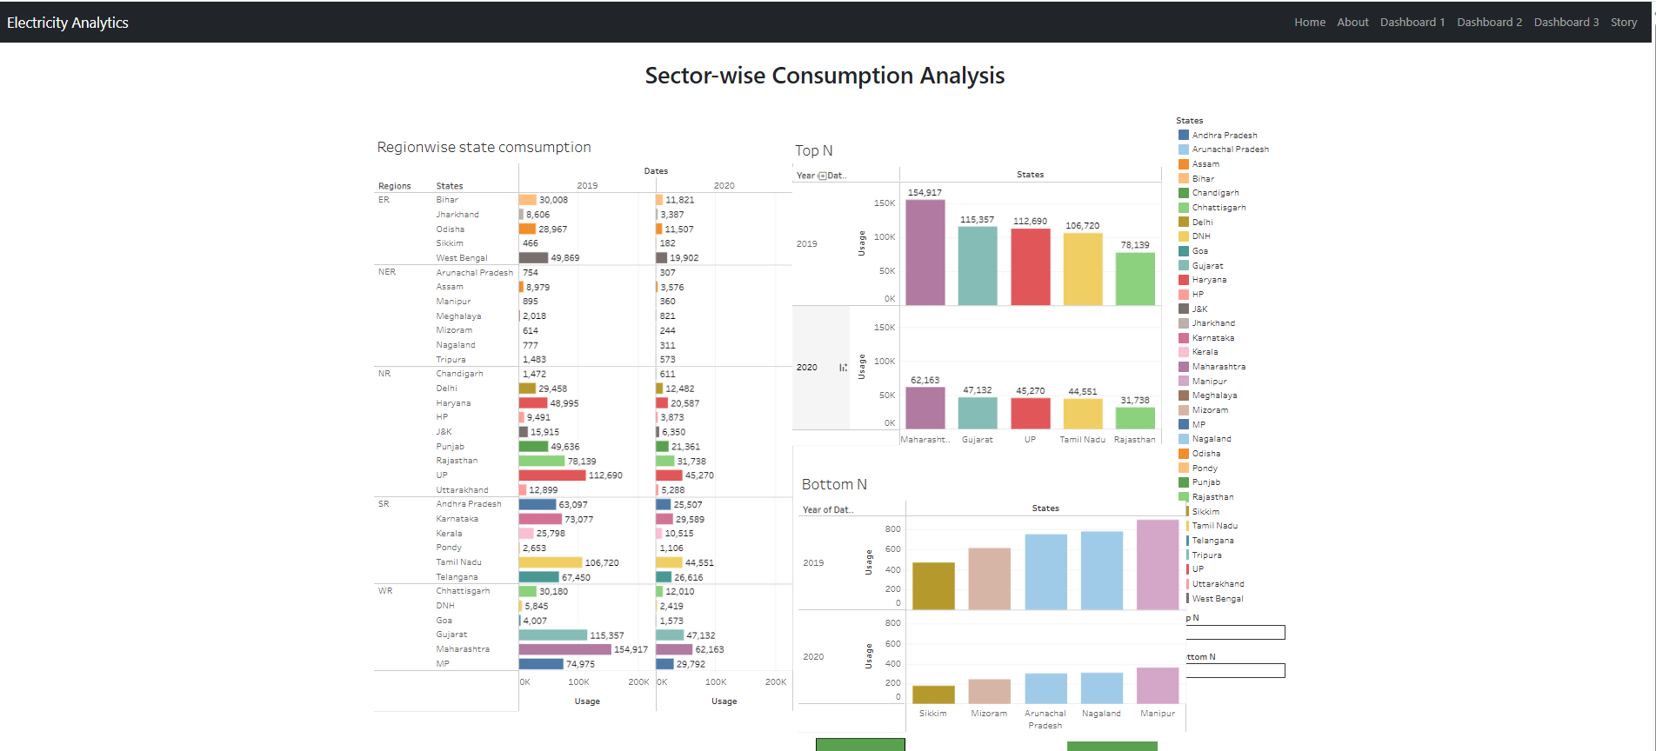

Story.html
<!DOCTYPE html>
<html>
<head>
<title>Story</title>
<link href="https://cdn.jsdelivr.net/npm/bootstrap@5.3.2/dist/css/bootstrap.min.css" rel="stylesheet">
</head>
<body>
<nav class="navbar navbar-expand-lg navbar-dark bg-dark">
<div class="container-fluid">
<a class="navbar-brand" href="/">Electricity Analytics</a>
<button class="navbar-toggler" type="button" data-bs-toggle="collapse" data-bs-target="#navbarNav">
<span class="navbar-toggler-icon"></span>
</button>
<div class="collapse navbar-collapse" id="navbarNav">
<ul class="navbar-nav ms-auto">
<li class="nav-item"><a class="nav-link" href="/">Home</a></li>
<li class="nav-item"><a class="nav-link" href="/about">About</a></li>
<li class="nav-item"><a class="nav-link" href="/dashboard1">Dashboard 1</a></li>
<li class="nav-item"><a class="nav-link" href="/dashboard2">Dashboard 2</a></li>
<li class="nav-item"><a class="nav-link" href="/dashboard3">Dashboard 3</a></li>
<li class="nav-item"><a class="nav-link" href="/story">Story</a></li>
</ul>
</div>
</div>
</nav>
<div class='tableauPlaceholder' id='viz1771054001081' style='position: relative'><noscript><a href='#'><img alt='Dashboard 3 ' src='https:&#47;&#47;public.tableau.com&#47;static&#47;images&#47;Bh&#47;Bharathsimha-Dashboard3&#47;Dashboard3&#47;1_rss.png' style='border: none' /></a></noscript><object class='tableauViz' style='display:none;'><param name='host_url' value='https%3A%2F%2Fpublic.tableau.com%2F' /> <param name='embed_code_version' value='3' /> <param name='site_root' value='' /><param name='name' value='Bharathsimha-Dashboard3&#47;Dashboard3' /><param name='tabs' value='no' /><param name='toolbar' value='yes' /><param name='static_image' value='https:&#47;&#47;public.tableau.com&#47;static&#47;images&#47;Bh&#47;Bharathsimha-Dashboard3&#47;Dashboard3&#47;1.png' /> <param name='animate_transition' value='yes' /><param name='display_static_image' value='yes' /><param name='display_spinner' value='yes' /><param name='display_overlay' value='yes' /><param name='display_count' value='yes' /><param name='language' value='en-US' /><param name='filter' value='publish=yes' /></object></div> <script type='text/javascript'> var divElement = document.getElementById('viz1771054001081'); var vizElement = divElement.getElementsByTagName('object')[0]; if ( divElement.offsetWidth > 800 ) { vizElement.style.width='100%';vizElement.style.height=(divElement.offsetWidth*0.75)+'px';} else if ( divElement.offsetWidth > 500 ) { vizElement.style.width='100%';vizElement.style.height=(divElement.offsetWidth*0.75)+'px';} else { vizElement.style.width='100%';vizElement.style.height='1477px';} var scriptElement = document.createElement('script'); scriptElement.src = 'https://public.tableau.com/javascripts/api/viz_v1.js'; vizElement.parentNode.insertBefore(scriptElement, vizElement); </script>
<div class="container mt-5">
<h2>Project Story</h2>
<p>
Electricity demand is increasing globally due to industrial growth,
urbanization, and technological advancement.
</p>
<p>
Using Tableau, we identified key patterns such as peak consumption
seasons, high-demand sectors, and future growth projections.
</p>
<p>
Insights from this analysis can support policy-making,
energy planning, and sustainable development.
</p>
</div>
</body>
</html>
